H.T No
Regulations:
A14

Sreenidhi Institute of Science and Technology
(An Autonomous Institution)
Code No: 4H111 Date: 18-Mar-2023 (AN)

B.Tech I-Year I- Semester External Examination, March-2023 (Supplementary)
ENGINEERING MATHEMATICS-I (Common to All Except BT)

Time: 3 Hours Max.Marks:70
Note: a) No additional answer sheets will be provided.
b) All sub-parts of a question must be answered at one place only, otherwise it will not be valued.
c) Missing data can be assumed suitably.

Bloom's Cognitive Levels of Learning (BCLL)

Remember | L1 | Apply | L3 | Evaluate | L5
Understand | L2 | Analyze | L4 | Create | L6

Part - A Max.Marks:20

Answer all QUESTIONS.

 |  | BCLL | CO(s) | Marks
1 | If 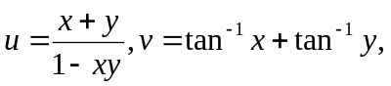find 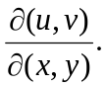 Are u and v functionally dependent? | L2 | CO1 | [2M]
2 | Discuss the structure of the differential equation 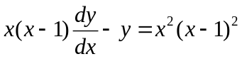and hence solve it. | L2 | CO2 | [2M]
3 | Find the general solution of 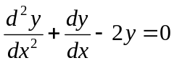. | L2 | CO3 | [2M]
4 | Evaluate 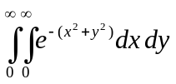 | L2 | CO4 | [2M]
5 | If 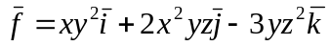, find 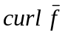at the point (1, -1, 1). | L2 | CO5 | [2M]
6 | Define line integral and surface integral. | L1 | CO6 | [2M]
7 | State Cauchy’s mean value theorem. | L1 | CO1 | [2M]
8 | Identify the area over the region R bounded by the curve y = x² and the line y = x. | L1 | CO4 | [2M]
9 | State Green’s theorem. | L1 | CO6 | [2M]
10 | Solve the differential equation (D² – 2D + 2y) = 0 | L1 | CO2 | [2M]

Part – B Max.Marks:50
ANSWER ANY FIVE QUESTIONS. EACH QUESTION CARRIES 10 MARKS.

 |  |  | BCLL | CO(s) | Marks
11. | a) | Verify Rolle’s theorem for the function 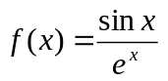in 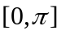 | L3 | CO1 | [5M]
 | b) | Are the functions 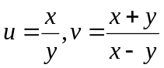functionally dependent? If so, find the relation between them. | L3 | CO1 | [5M]
12. | a) | Solve (x + y + 1) dy = dx. | L3 | CO2 | [5M]
 | b) | Solve 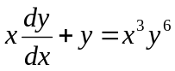 | L3 | CO2 | [5M]
13. | a) | Solve (D² + 1)y = cos x by the method of variation of parameters. | L3 | CO3 | [5M]
 | b) | Solve (D² + 1)y = sin x sin 2x | L3 | CO3 | [5M]
14. | a) | Evaluate 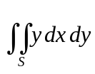 where R is the region bounded by the parabolas  y² = 4x and x² = 4y. | L3 | CO4 | [5M]
 | b) | Evaluate 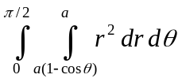 | L3 | CO4 | [5M]
15. | a) | Show that the vector 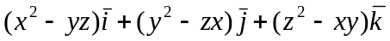is irrotational and find its scalar potential. | L3 | CO5 | [5M]
 | b) | If 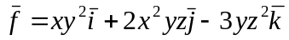, find its curl at the point (1, -1, 1). | L3 | CO5 | [5M]
16. | a) | By transforming into triple integral, evaluate 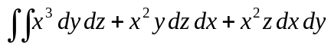where S is the closed surface consisting of the cylinder  x² + y² = a². | L3 | CO6 | [5M]
 | b) | Apply Green’s theorem to evaluate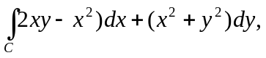 where C is bounded by y = x² and x = y². | L3 | CO6 | [5M]
17. | a) | Write the statements of Lagrange’s and Cauchy’s mean value theorems. | L2 | CO1 | [4M]
 | b) | Define order and degree of a differential equation and give one example. | L2 | CO2 | [3M]
 | c) | Solve 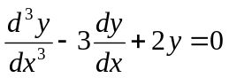 | L2 | CO3 | [3M]
18. | a) | Evaluate 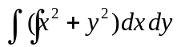in the positive quadrant for which 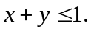 | L3 | CO4 | [4M]
 | b) | If 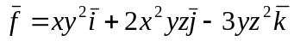, find 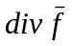at (1, -1, 1). | L2 | CO5 | [3M]
 | c) | What is the statement of Stoke’s theorem. | L2 | CO6 | [3M]

-- 00 -- 00 –

